Scenario Analysis

Varying the acceleration

(while keeping the following the same: ticks=500, grid-size-x = 3, grid-size-y = 3, num-cars = 50, power? = true, ticks-per-cycle = 20, speed-limit = 1, current-auto? = true, current-phase = 0%)

Test 1 (acceleration = 0.099, 50 cars)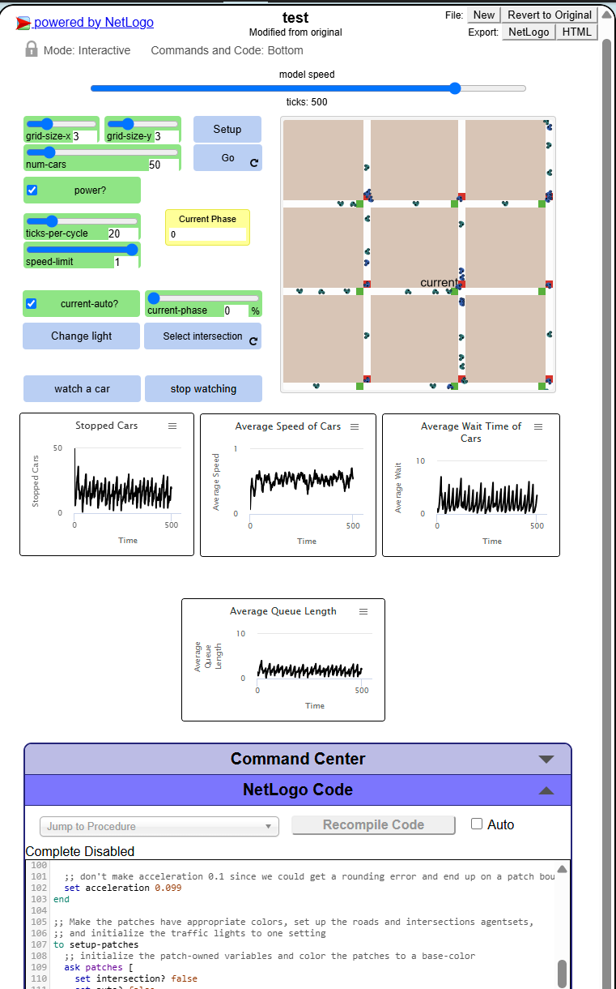

Test 2 (acceleration = 0.0792, 40 cars) - %20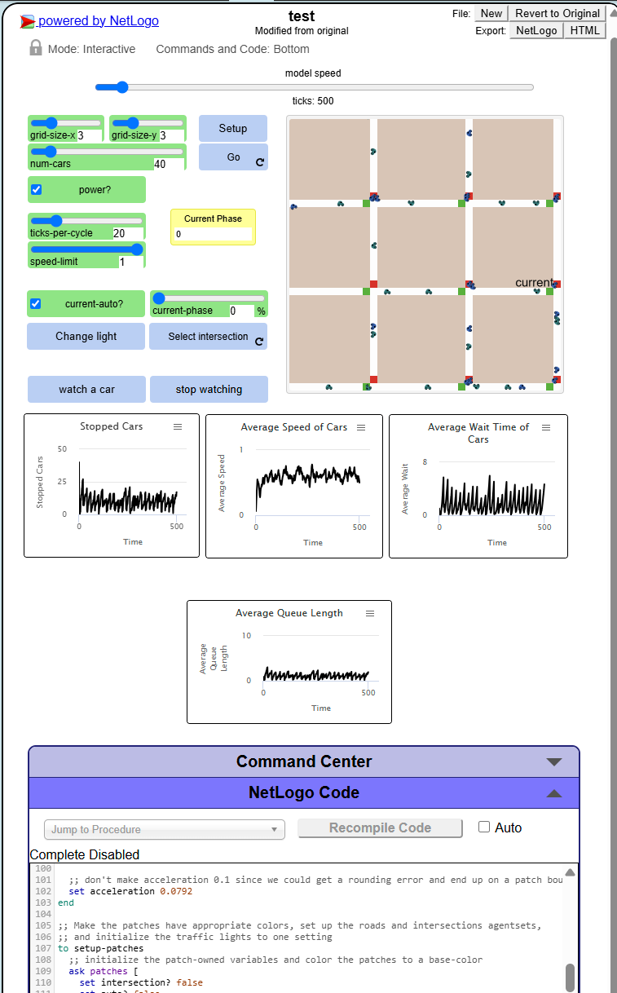

Test 3 (acceleration = 0.1188, 60 cars) + 20%